

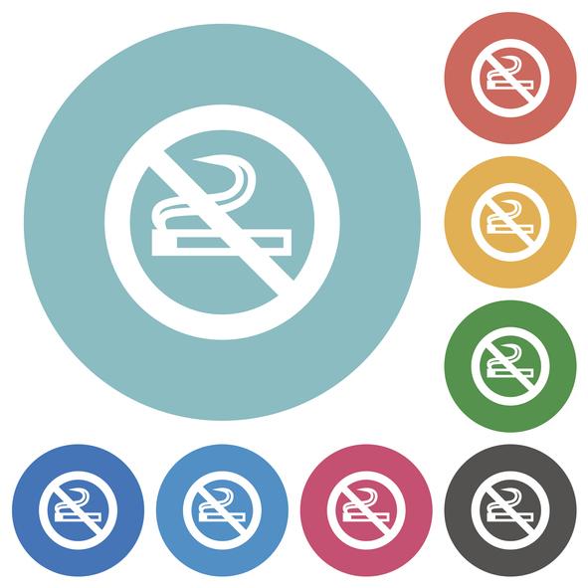

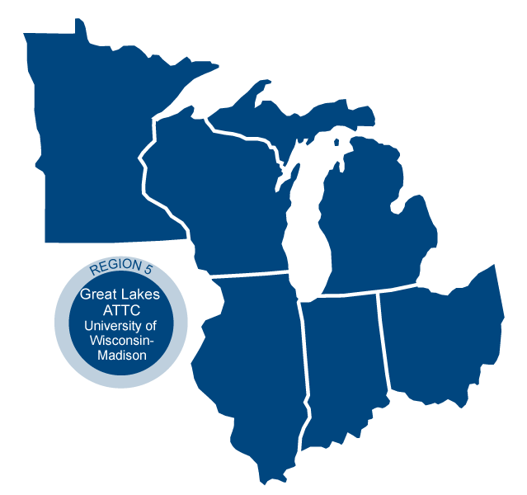



**Using Motivational Interviewing in Behavioral Health Settings**

This session will explore how this evidence-based communication style can increase capacity to effectively engage people in their own care and make changes to support their health. You will develop a few of the necessary skills to access motivation and strengthen commitment to change.  This session will introduce fundamental concepts, and will offer opportunities to improve your communication no matter your current skill level.

**When:**

Wednesday 8/7/19- Thursday 8/8/19, 8:30am-4:30pm

*Hour long lunch is on your own each day

**Coaching calls via Zoom for implemention questions and addressing barriers**:

9/10/19, 9/17/19, 10/1/19, 12:00-1:00pm

*Calendar invitiations with Zoom call-in information will be sent out after the training.

**Where:**

St Cloud State University

Eastman Hall

850 1st Ave

Room 116

St Cloud, MN, 56301

**Who Should Attend:** This workshop is for any helping professional who works directly with other people who are reluctant to change their attitudes, behaviors and/or thoughts. In other words, everyone!

**Learning Objectives**

* Identify the key domains of the spirit of Motivational Interviewing (MI)
* Utilize the core skill of reflective listening to demonstrate empathy
* Employ the strategic objective of responding to and evoking change talk

**For more information, contact:**

**Kris Kelly: email:** [Kris.kelly@wisc.edu](mailto:Kris.kelly@wisc.edu) **phone**:612-986-4906

**Presenter**

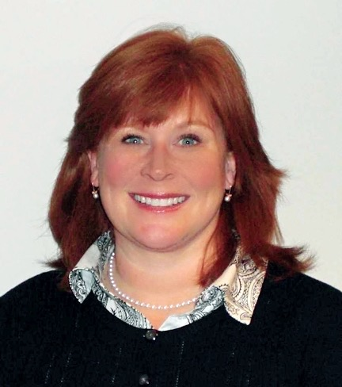

**Laura Saunders, State Project Manager, Wisconsin  
*Great Lakes ATTC, MHTTC, and PTTC***

Laura A. Saunders, MSSW, is the Great Lakes Addictions, Mental Health and Prevention Technology Centers: State Project Manager for the State of Wisconsin.  Her position is housed at the University of Wisconsin-Madison where she’s worked since 1988.  Since 2001, Laura has provided SBIRT and Motivational interviewing training to physicians, nurses, medical students, psychologists, specialty addiction treatment providers, social workers, physical therapists, health educators and staff who work in correctional settings. She has provided feedback and coaching to hundreds of social workers, correctional staff  and other human service providers who are interested in using EBP’s fidelity.   She joined the International group of Motivational Interviewing Network of Trainers (MINT) in 2006 (Sophia, Bulgaria) and is an active member of the Wisconsin MINT group.

.

The Great Lakes PTTC is located at the University of Wisconsin-Madison Center for Health Enhancement Systems Studies. We are funded by [SAMHSA](http://www.samhsa.gov/) to support the behavioral health workforce in HHS Region 5: IL, IN, MI, MN, OH, and WI.

Visit our website at: [www.pttcnetwork.org/greatlakes](http://www.pttcnetwork.org/greatlakes)