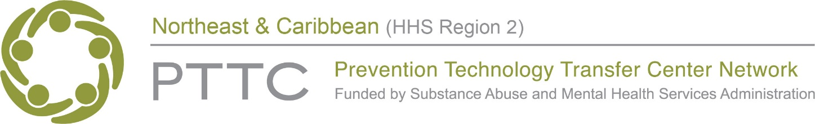

The HHS Region 2 Northeast and Caribbean Prevention Technology Transfer Center presents
Parents and Caregivers: Powerful Partners in Prevention
A two-part virtual learning event for prevention practitioners in Region 2

Webinar: Tuesday, May 24, 2022

1:00 PM – 2:30 PM (EST/AST)

As anyone who has ever hosted an event for parents and caregivers with low attendance can attest, engaging caregivers in prevention efforts is no easy task. Yet, as prevention practitioners, we know that getting caregivers to the table has a direct impact on the success of our efforts. This two-part virtual learning series will explore the parent/caregiver role in preventing youth substance misuse. Session One (webinar) will delve into the power of parents’ own beliefs in determining whether substance misuse is seen as preventable or inevitable. It will also highlight the many risk and protective factors that parents have the ability to influence in their own homes and in the broader community, and will highlight both evidence-based and promising practices for engaging parents/caregivers in prevention efforts. Session two (peer-sharing call) will lift up voices and examples from our region to share lessons learned from both successful and challenging experiences from bringing parents/caregivers to the prevention table.

Parent session (webinar) LOs
- Describe the importance in developing parents’ belief in their own efficacy in preventing their child’s substance misuse.
- Educate parents about their role in addressing the factors that influence youth substance misuse.
- Discuss strategies for resolving barriers to parent participation in prevention planning efforts and services.
- List evidence-based and promising practices to support parent engagement in prevention efforts.

Attending both sessions is recommended but not required.
CLICK HERE TO REGISTER FOR SESSION 1

Questions or having trouble registering?
Please contact cneary@ssw.rutgers.edu

