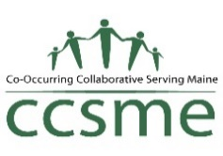
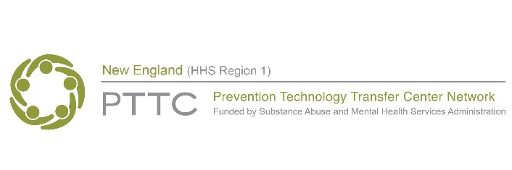
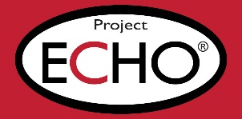

Project ECHO: Addressing Alcohol Misuse Prevention for the 21st Century
Alcohol continues to be the most widely misused substance in our communities with harmful impacts on health outcomes across the lifespan. Nationally, excessive alcohol use contributes to more than 140,000 deaths each year, including over 6000 deaths each year in New England alone. However, evidence-based prevention strategies can be effective in reducing alcohol misuse when prevention professionals have the tools and knowledge to advocate for strong alcohol policies and community approaches to alcohol prevention.
Through this Project ECHO, we will seek to provide support and education for substance misuse prevention professionals to address issues related to alcohol misuse in their states and communities with strategies supported by prevention science. The overall goal of this ECHO is to increase the use of evidence-based approaches for alcohol misuse prevention among prevention professionals in New England.
Learning Objectives: At the conclusion of the Project ECHO, participants will be able to:
- Describe trends in youth and adult alcohol consumption at the local, state or national level.
- Identify current evidence-based strategies to prevent youth and young adult alcohol misuse.
- Compare environmental and policy approaches that are effective for alcohol misuse prevention
- Discuss the intersection of prevention and equity as it relates to alcohol and other substance use and misuse.
Project ECHO®: Project ECHO (Extension for Community Health Outcomes) is an evidence-based distance learning method developed by researchers at the University of New Mexico, in which a group of faculty experts meets regularly with a participant cohort to engage in case-based discussion and learning. Using this format, this group will meet for 1 hour via Zoom videoconference twice per month for 3 months (7 total sessions). Each session will include a brief expert-led educational segment and an extended participant-led case discussion. This Project ECHO is hosted by CCSME, a Project ECHO Hub site, in partnership with the New England PTTC.

Apply here: https://forms.gle/2eLaYXdvQkZEyV3a6
Selected topics:
- Current data and trends on alcohol use and misuse
- Alcohol policy, control and enforcement
- Effective alcohol misuse prevention strategies for youth and adults
- Communicating and messaging substance use information to different audiences
Faculty:
- Amelia Arria, PhD, Professor, Director, Center on Young Adult Health, University of Maryland
- Rebecca Ireland, MPH, PS-C, Prevention Specialist & Consultant
- Elizabeth Parsons, M.Ed, Director, Center for Alcohol Science to Practice
- Scott Gagnon, MPP, PS-C, Director, New England PTTC
Faculty include subject matter experts with expertise in alcohol misuse prevention, policy and science at the community, state and federal level. Additional guest speakers may also participate.

Participant Expectations:
- Participate in at least 4 of 7 ECHO sessions
- Complete pre- and post-ECHO participation surveys
- Actively engage in group discussion around didactic presentations and case presentations throughout ECHO sessions
- Share new knowledge gained with peers, colleagues, and community to continue knowledge-sharing effect across New England
Eligibility for Participation:
- Work in a New England state (CT, MA, ME, NH, RI, VT)
- Participants are encouraged to apply as a team (2-6 people) from an organization, coalition or program working on prevention of alcohol misuse. Team members can also be from more than one organization who work closely together.
  - Individuals are also eligible to apply
- At least 1 year of general prevention experience is recommended.
Schedule: ECHO will meet on the 2nd and 4th Thursday of the month, from 12:00-1:00 pm, beginning January 25, 2024.
- January 25
- February 8
- February 22
- March 14
- March 28
- April 11
- April 25

About this program:
This program was developed to provide advanced training for the prevention of alcohol misuse within New England states (CT, MA, ME, NH, RI, VT). This program is intended for substance misuse prevention practitioners within the New England region who are working on alcohol misuse prevention initiatives. This program is coordinated and hosted through CCSME, which is a licensed Project ECHO Hub and a partner in the New England PTTC. Participants will be asked to create a free iECHO account to access the virtual meeting platform (instructions will be provided).

If you are unable to access the application in Google Forms, please email kerickson@ccsme.org for an alternative.

